**Monte Carlo Simulation Tool**

*A modern Java GUI application for visualizing the convergence of Monte Carlo simulations with an interactive, real-time plotting interface.*

**Overview**

This desktop application provides an intuitive and visually compelling way to perform Monte Carlo simulations for estimating the probability (𝑋<0.5) P(X<0.5) from uniformly distributed random samples in [0,1)[0,1). The application uses Java Swing to create a modern GUI, featuring real-time plotting of convergence behavior, responsive input handling, and professional styling.

**Core Functionality**

* **Objective**: Estimate (𝑋<0.5)P(X<0.5) by simulating a large number of samples.
* **Visualization**: Displays a real-time line chart showing convergence to the true probability value (0.5)

**GUI Preview**

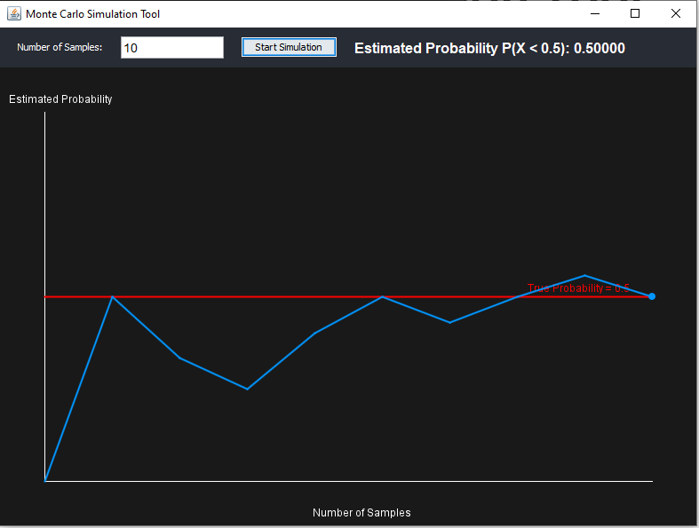

**Features**

**Mathematical Accuracy**

* Monte Carlo estimation using uniform random samples
* Real-time calculation of running estimates
* Convergence toward true theoretical probability

**Usage Example**

* Steps to Use: Enter the number of samples (example:1000) into the input field.
* Click Start Simulation.
* View the convergence graph and the estimated probability.

**Example Output**

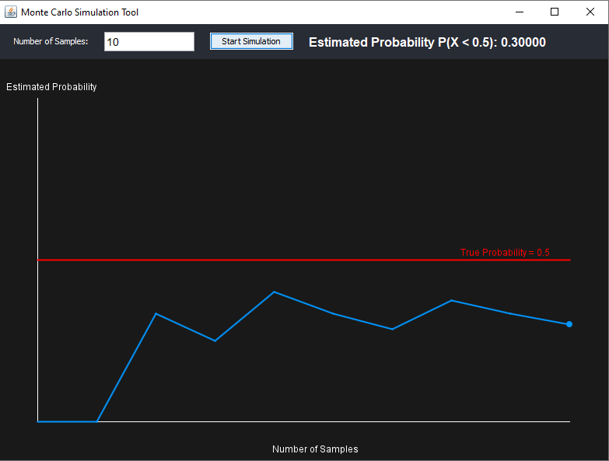

**Mathematical Implementation**

**Monte Carlo Method**

This simulation uses the basic principle of Monte Carlo integration:

* Generate 𝑁 N uniform random numbers 𝑥∈[0,1)x∈[0,1)
* Count how many of them are less than 0.5
* 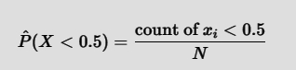Estimate the probability as:

**[n% I = w]**  
**Group Members:***Lee Ivan Sahurda  
John Gilbert Balbuena  
Emmanuelle Christian Obrero*